The Existing workflow:
Products are inserted in the Transfer server database in the following structure:
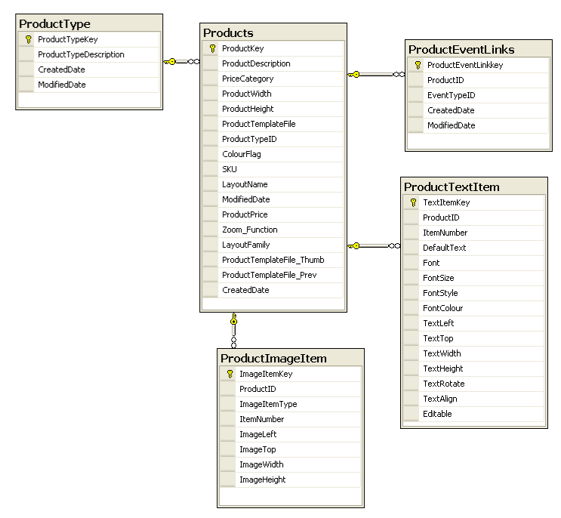
The ProductKey represents the ProductKey in the Lab database, so that orders placed using this productKey are known to the Halse system.
ProductEventLinks Transfer server only -determine which products will be available for which pictures,
ProductTypes: Transfer server only. Values at present:
1 | Image
2 | Folio
3 | Email
4 | Photo Album
5 | Slideshow
6 | Delivery
7 | Wedding Book
8 | Guest CD
9 | DnP_CD
10 | DnP_CD_With_Index
11 | Express Delivery
12 | Voucher
13 | Promo (Standard Discount)
14 | Promo (Group Discount)
15 | Promo (Quantity Discount)
16 | Promo (Combo Buy X,Y,Z Get % Discount)

Orders are created on the transfer server using the following structure: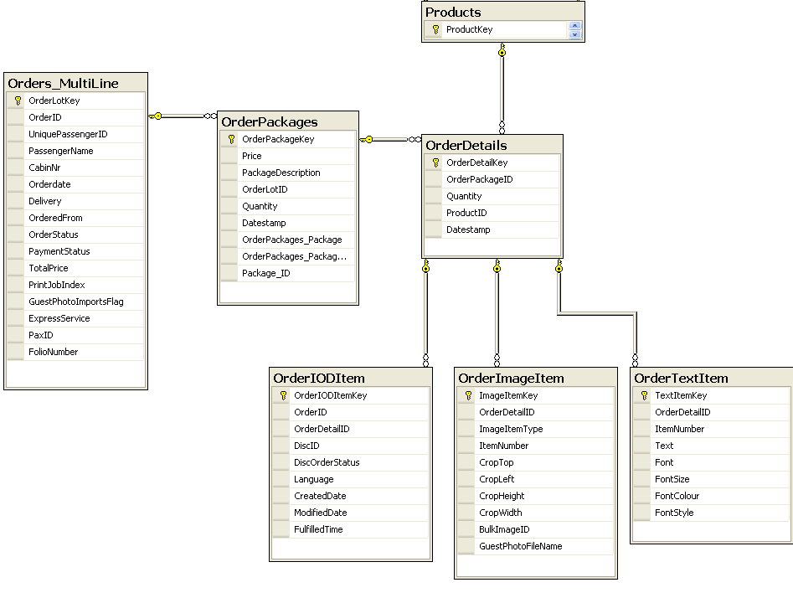
The Order Details level represents an ordered instance of a product by linking to the ProductID (Key), and the OrderImageItem and OrderTextItem represent Instance-specific information required for the ProductImageItem and ProductTextItem respectively.
From this information, a Kiosk Order is generated in the Halse Lab side system.
This has recently had the addition of the OrderIODItem, which represents an Images-On-Disc product which is fulfilled through a slightly different method.

